**How does a C++ program run**

A C++ program begins execution at the main function. The main function is a special function in C++ that is called when the program starts. It is the entry point of the program and is usually where the program's logic is implemented.

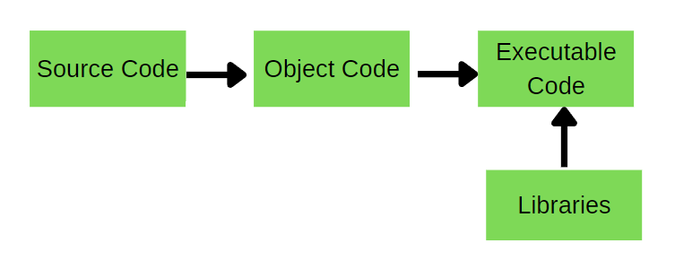

Before the main function is called, the C++ compiler performs several tasks, including:

Preprocessing: The C++ preprocessor processes all of the preprocessor directives in the program, such as "#include" and "#define". These directives are replaced with the contents of the included files or the defined constants.

Compiling: The C++ compiler translates the preprocessed source code into machine code, which is a low-level code that can be executed by the computer's processor.

Linking: The linking process combines the compiled object files and any external libraries used by the program into a single executable file.

Once the program has been compiled and linked, it can be run. The program will start executing at the main function and will continue to execute the code within the main function until it reaches the end. The main function must return an integer value to indicate the success or failure of the program.